**Mining Solutions with Abrasion Resistant Steel**

The mining industry operates under demanding conditions, requiring robust equipment to extract valuable resources from the earth's surface. One solution to these challenges lies in the integration of specialized wear parts designed to tackle the abrasive nature of mining processes. These wear parts are meticulously tailored to the unique requirements of mining operations, offering a range of tangible benefits. These include cost reductions, extended equipment lifespan, minimized downtime, and optimized personnel costs.

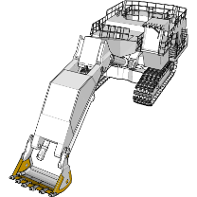**Front Shovel Buckets: Optimizing Wear Performance**

Front shovel buckets are crucial tools in mining, tasked with moving substantial volumes of earth and minerals. However, the abrasive materials they handle result in rapid wear. To address this issue, a range of wear parts has been developed to enhance the longevity and efficiency of these buckets. Incorporating advanced abrasion-resistant steel wear plates, such as Abrasion Resistant Steel 500, presents a solution that offers long-term advantages. These include an extended service life, reduced downtime for maintenance, and enhanced overall efficiency, surpassing the performance of conventional bucket designs.

**Grades:** AR400 or AR450 steel is a good choice for front shovel buckets. These steel grades are hard enough to resist wear from the rocks and other materials being dug up, but they are also ductile enough to be formed and machined.

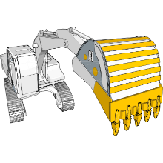**Power Shovel Buckets: Durability and Savings**

Power shovel buckets are essential for excavating fragmented rocks and minerals. The continuous digging, swinging, and dumping actions expose these buckets to intense wear. To combat this challenge, a tailored approach involves the integration of specialized materials. High-strength steel for cutting edges, along with the toughness of Abrasion Resistant Steel for wear bars, ensures cost savings through minimized maintenance needs, easier upkeep, and significantly prolonged bucket lifespan.

**Grades:** AR450 or AR500 steel is a good choice for power shovel buckets. These steel grades are harder than AR400 steel, making them more resistant to wear.

**Dragline Buckets: Lightweight Efficiency for Surface Mining**

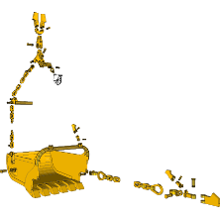

In surface mining, dragline buckets play a pivotal role in removing overburden, particularly in coal mining. These buckets experience substantial loads and consistent abrasion during their operations. Transitioning to wear plates made from abrasion-resistant steel offers multiple benefits, including reduced bucket weight, extended service life, and enhanced operational efficiency. This change optimizes both productivity and cost-effectiveness.

**Grades:** AR500 or AR600 steel is a good choice for dragline buckets. These steel grades are very hard and resistant to wear, making them ideal for applications where the material being dug is very abrasive.

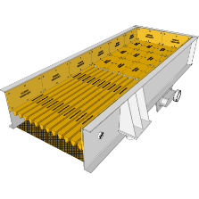**Feeders: Prolonged Service Life**

Feeders are indispensable for transporting smaller materials in mining operations. Due to the abrasive nature of these materials, feeders often deteriorate quickly. Utilizing abrasion-resistant steel in the construction of feeder liners significantly extends their service life. This strategic adaptation empowers feeders to handle challenging materials like metal waste and iron ore pellets, ensuring sustained efficiency and durability.

**Grades:** AR400 or AR450 steel is a good choice for feeders. These steel grades are hard enough to resist wear from the materials being fed, but they are also ductile enough to be formed and machined.

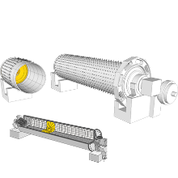**Ball Mills: Extended Lifespan for Grinding Applications**

Ball mills play a central role in various industrial processes by grinding and blending materials. The grinding process subjects these mills to abrasive wear, making abrasion-resistant materials vital for their construction. Incorporating abrasion-resistant steel in inlet chutes and gratings further extends the service life of ball mills. This adaptation minimizes downtime, maintenance costs, and the need for frequent replacements, promoting efficiency and cost savings.

**Grades:** AR500 or AR600 steel is a good choice for ball mills. These steel grades are very hard and resistant to wear, making them ideal for applications where the material being ground is very abrasive.

**Skips and Bins: Reliable Material Handling**

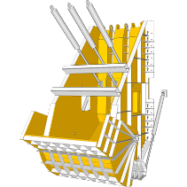

Skips and bins are integral for loading, transporting, and storing abrasive materials in mining. The harsh operational conditions these components face result in wear and impact damage. Utilizing abrasion-resistant steel for wall and floor lining significantly enhances their strength, reduces weight, and extends their service life. This solution directly contributes to efficient and durable material handling.

**Grades:** AR400 or AR450 steel is a good choice for skips and bins. These steel grades are hard enough to resist wear from the materials being transported, but they are also ductile enough to be formed and machined.

**Railway Hopper Cars: Efficient Transportation with Enhanced Liners**

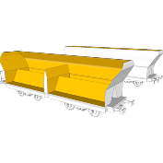

Railway hopper cars are vital for transporting bulk commodities and freight, but they face abrasion during loading and unloading. Enhanced durability can be achieved by integrating abrasion-resistant steel for hopper car liners. This adaptation reduces maintenance needs and extends the overall service life of hopper cars, optimizing transportation efficiency.

**Grades:** AR450 or AR500 steel is a good choice for railway hopper cars. These steel grades are harder than AR400 steel, making them more resistant to wear.

**Cyclones: Effective Separation with Enhanced Protection**

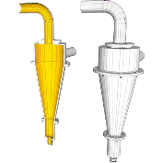

Industrial cyclones play a crucial role in separating solids from gases or liquids. Operating under abrasive conditions, the walls of these cyclones require protection. Implementing wear-resistant components, such as abrasion-resistant steel wear plates, ensures the longevity and efficiency of cyclones. This solution safeguards against abrasion, enabling cyclones to maintain optimal performance over extended periods.

**Grades:** AR500 or AR600 steel is a good choice for cyclones. These steel grades are very hard and resistant to wear, making them ideal for applications where the material being separated is very abrasive.